Launching Microsoft SQL Server
To launch Microsoft SQL Server, click Start -> Programs -> Microsoft SQL Server 2005 -> SQL Server Management Studio.

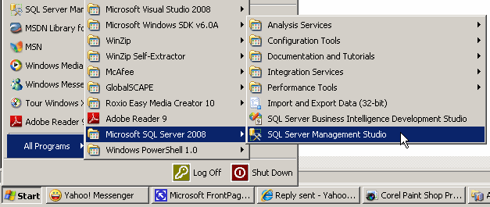
When it starts, it would present a dialog box that expects you to log in.

Introduction to Code
Although you will perform many of your database operations visually, some other operations will require that you write code. To assist with this, Microsoft SQL Server provides a code editor and various code templates.
To open the editor:
- On the main menu, you can click File -> New -> Query With Current Connection
- On the Standard toolbar, click the New Query button
- In the Object Explorer, right-click the name of the server and click New Query
This would create a new window and position it on the right side of the interface.
Executing a Statement
In the next sections and lessons, we will learn various techniques of creating SQL statements with code. By default, when a new query window appears, it is made of a wide white area where you write your statements:
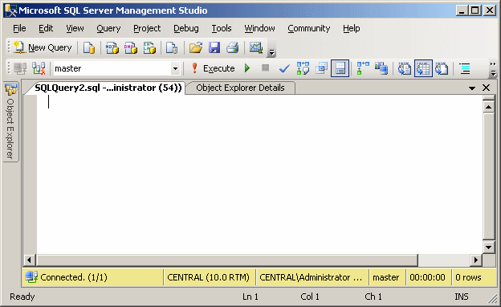
After writing a statement, you can execute it, either to make it active or simply to test it. To execute a statement:
- You can press F5
- On the main menu, you can click Query -> Execute
- On the SQL Editor
toolbar, you can click the Execute button
- You can right-click somewhere in the code editor and click Execute
When you execute code, code editor becomes divided into two horizontal sections:
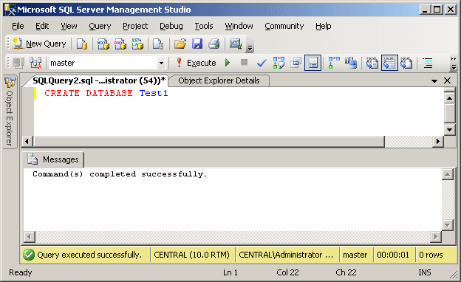
Whether you have already written code or not, you can save the document of the code editor at any time. To save it:
- You can press Ctrl + S
- On the main menu, you can click File -> Save SQLQueryX.sql...
- On the Standard toolbar, you can click the Save button

- In the Object Explorer, right-click Databases and click New Database...
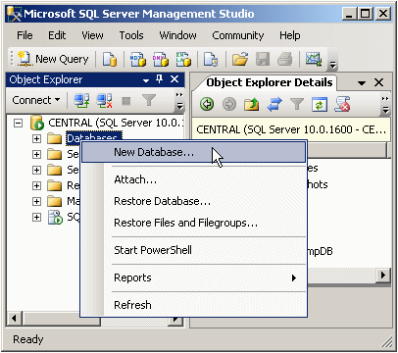

- In the Name text box, type MotorVehicleAdministration
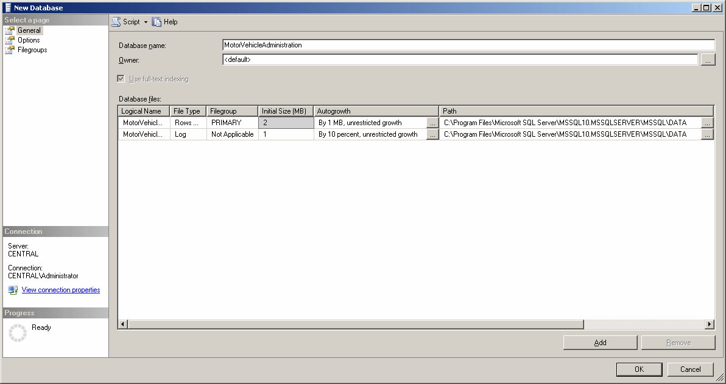
Creating a Table
- In the Object Explorer, expand the BCR node (click its + button)
- Under BCR, right-click Tables and click New Table...
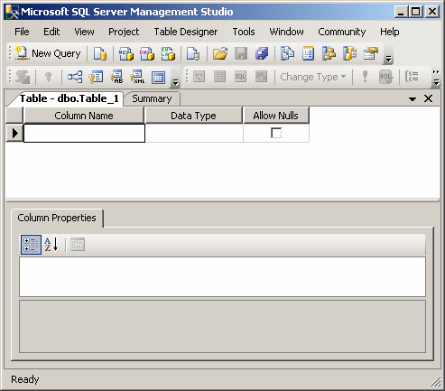
- As the cursor is blinking in the first empty field under the Column Name column, type name and press Enter
- To save your table, on the Standard toolbar, click the Save button
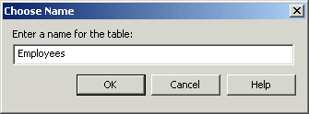
- In the Choose Name dialog box, type Employees and press Enter
- After saving the table, close it by clicking its system Close button
- Click the arrow of the combo box under the Data Type column
- Scroll down and select varchar from the list
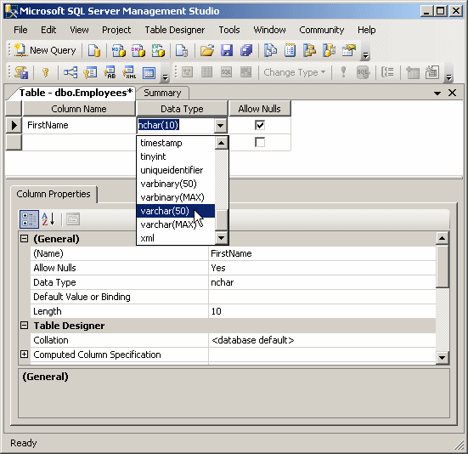
- Click the first empty field under FirstName and type MI
- Press the down arrow key to position the cursor under MI
- Type LastName and press the down arrow key
- Type DateHired
- Press Tab and type d
- Notice that the datetime data type is selected.
- Press Enter three times to position the mouse cursor under DateHired
- Type EmployeeNumber and press the down arrow key
- Complete the table as follows:
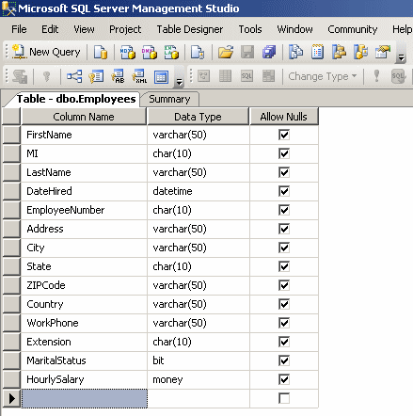
- Save the table.

How to backup and restore database on Microsoft SQL Server 2005
This post shows a step-by-step guide to backup and restore a database between two Microsoft SQL Server 2005 instances. By using backup, you can backup a database without interrupt any transactions on the database.
In the example below, I will backup a database from SQL Server 2005 and restore the database to another SQL Server 2005 Express Edition.
Now I will backup AdventureWorks database on BKKSQL2005 which runs Microsoft SQL Server 2005 to a file.
- Connect to source server. Open Microsoft SQL Server Management Studio and connect to BKKSQL2005.
- Right-click on the AdventureWorks database. Select Tasks -> Backup…
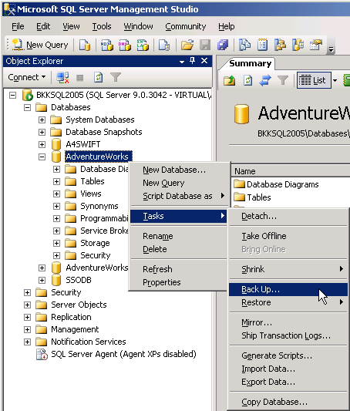
- On Back Up Database window, you can configure about backup information. If you’re not familiar these configurations, you can leave default values. Here are some short descriptions.
  - Database - a database that you want to backup.
  - Backup type - you can select 2 options: Full and Differential. If this is the first time you backup the database, you must select Full.
  - Name - Name of this backup, you can name anything as you want.
  - Destination - the file that will be backup to. You can leave as default. Default will backup to “C:\Program Files\Microsoft SQL Server\MSSQL.1\MSSQL\Backup”.
  - Click OK to proceed backup.
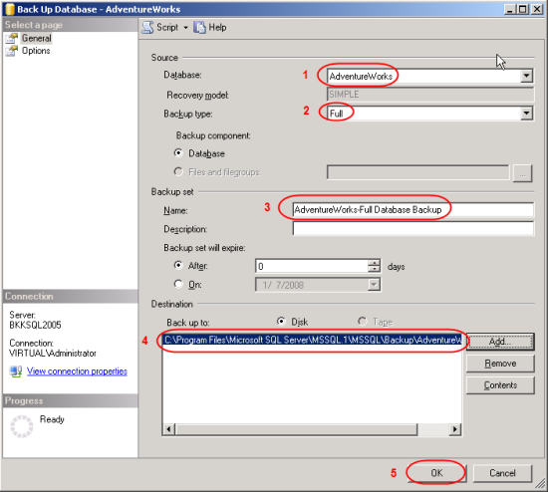
- Wait for a while and you’ll see a pop-up message when backup is finished.
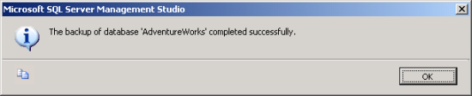
- Browse to the destination, you’ll see a backup file (.bak format) which you can copy to other server for restore in the next step. Default backup directory is “C:\Program Files\Microsoft SQL Server\MSSQL.1\MSSQL\Backup”.
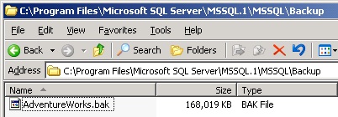
Restore the database.
Next, I will restore the AdventureWorks database from a file that I’ve created above to BK01BIZ001 which runs Microsoft SQL Server Express Edition.
- Copy the backup file from source server to destination server. I’ve copied into the same directory as source server.
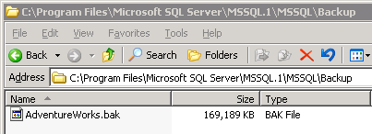
- Connect to destination server. Open Microsoft SQL Server Management Studio Express and connect to BK01BIZ001.
- Right-click on Databases. Select Restore Database…
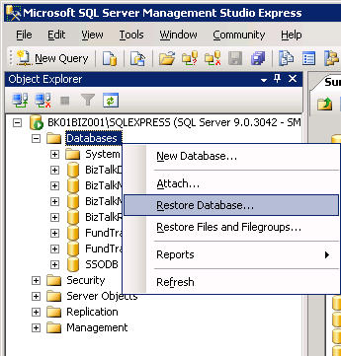
- Restore Database window appears. On Source for restore, select From device and click [...] buttton to browse file. 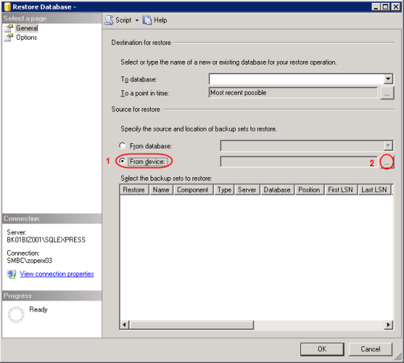
- On Specify Backup, ensure that Backup media is “File” and click Add.
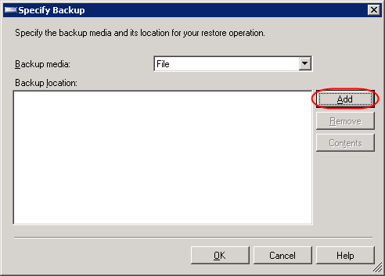
- On Locate Backup File, select the backup file. This is the backup file that was created in Backup a database section and was copied to this server. Click OK. OK.
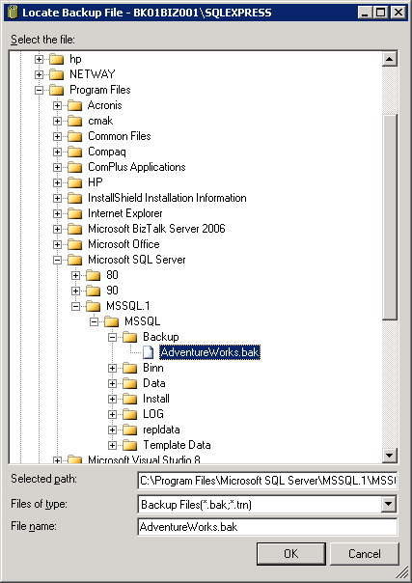
- Back to Restore Database window.
  - On Destination for restore, select “AdventureWorks”.
Note: If you haven’t added the backup file on Source before (step 4-6), you won’t see the database name on Destination.
  - On Source for restore, check the box in front of the backup name (in Restore column).
  - Click OK.
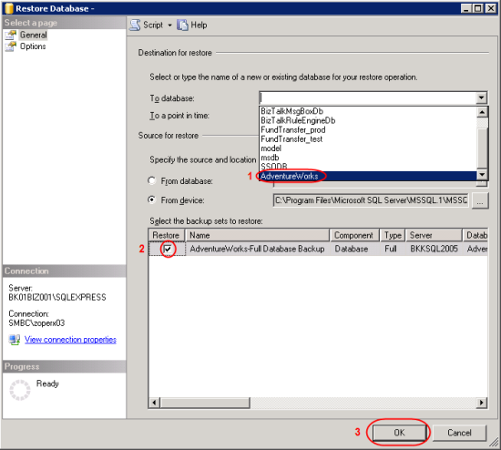
- Wait until restore finish and there’ll be a pop-up message notify.
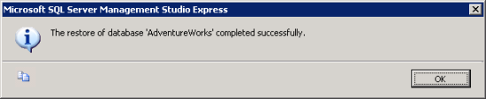
- Now you’ll see the restored database on the destination SQL Server.
